


Mr Shane O'Meara and Mrs Jenny O'Meara
of

4 Balmerino Square
FRANKSTON VIC 3199

Telephone: 9479 5877
Email: shaneom@westnet.com.au

Prepared by

Andrew Lord B Bus (Acc), Dip FS (Fin Plan)

Level 9, 606 St Kilda Road
Melbourne VIC 3004

Telephone: (03) 9510 0788

Fax: (03) 9510 0799

Email: andrewl@lakesideconsultants.com.au

Authorised Representative 324798

of

Guardianfp Ltd trading as Guardian Financial Planning
ABN 40 003 677 334 Australian Financial Services Licensee No. 237641
Level 10, 321 Kent Street, Sydney, NSW, 2000
Phone: 1300 720 350 Fax: 02 8275 3232 E-mail: enquiries@guardianfp.com.au

4th November 2010 

What this document is about
This Statement of Advice (or SoA) is an important document.
- It provides you with information about our advice so you can make a decision about implementing the advice.
- It should be read in conjunction with other documents such as Product Disclosure Statements and our Financial Services Guide.

What to do after reading this Statement of Advice
Please contact us.
- If you have any questions.
- If we have omitted, overlooked or incorrectly understood any of your relevant circumstances.
- When you are ready to implement the recommendations.
- Or, if you decide you want to do something else and need our advice or assistance.

4 November 2010

Mr Shane O'Meara and Mrs Jenny O'Meara
4 Balmerino Square
FRANKSTON VIC 3199

Dear Shane and Jenny,

I am pleased to enclose your Statement of Advice (SoA).

It is an important document that you should read and understand before making a decision to proceed further.

We have based the strategies and recommendations in this document on our understanding of your current personal and financial position. If any of this information does not reflect any part of your current position, goals and objectives please advise us immediately and we will make the necessary changes.

The SoA sets out our recommended strategies to address your needs, together with a recommended course of action to implement these strategies.

When you are ready to proceed, we would be very happy to help you with the implementation of the advice, including the completion and lodgement of application forms and other documents.

Please note, our recommendations in this Statement of Advice are valid for 30 days from the date on the cover of this document. If your circumstances change before you implement our recommendations, or if you don’t act on them within 30 days, they may no longer be appropriate for you. If that happens, please ask us to review your situation again before you take any action.

Once implemented, we should review your situation on a regular basis to ensure we make the most of any changes that may impact on the strategies I have recommended for you.

Yours sincerely,

Andrew Lord

B Bus (Acc), Dip FS (Fin Plan)
Authorised Representative No.324798 of
Guardianfp Ltd trading as Guardian Financial Planning

Table of Contents
Purpose of this document 5
Timeframe for our advice 5
Check for accuracy 5
Limitations of our advice 5
Thank you for choosing Guardian Financial Planning 6
Product selection 6
Introduction 7
The Scope of Our Advice 7
Our Investment Recommendations 7
Your Adviser 8
The Planning Process 8
Executive Summary 9
Your Goals and Objectives 9
Recommendation Overview 9
Anticipated Outcomes 10
Future Strategies 10
Personal Information 11
Personal Details 11
Health Details 11
Employment Details 11
Dependants 11
Estate Planning 11
Assets and Liabilities 12
Current Risk Management Policies 14
Income and Expenses 15
Your Investor Risk Profile 17
Strategy Recommendation 19
Your Existing Investments 19
Retirement Planning - (Prior to recommendations) 20
Superannuation Funds 21
Transition to Retirement 23
Pre-Retirement Income Stream 23
Superannuation Contribution Limits 25
Salary Sacrifice to Superannuation 26
Reversionary Pensions 29
Estate Planning 30
Wills and Testamentary Trusts 30
Non Estate Assets 31
Powers of Attorney 32
Risk Management 33
Personal Insurance - Review Recommendation 33
Existing Cover Amounts 33
Investment Recommendations 34
Current Portfolio 34
Proposed Portfolio 35
Projected Portfolio Profile Compared to Benchmark 37
Replacement of an Existing Product 42
What is paid to your adviser 47
Plan Fee 47
Upfront and Ongoing Fee Disclosure 47
Disclosure Statement 48
Summary 51
Appendix – Assumptions 53
Authority to Proceed 54

Purpose of this document

The following Statement of Advice (SoA) is an outline of the financial plan discussed with your financial planner. It details the recommendations needed to execute your plan and achieve your financial objectives.

Timeframe for our advice

Our recommendations in this SoA are valid for 30 days from the preparation date on the cover of this document. If your circumstances change before you implement our recommendations, or if you don’t act on them within 30 days, they may no longer be appropriate for you. If that happens, please ask us to review your situation before taking any action.

Check for accuracy

This SoA is based on the information you provided. Please read the document carefully, checking that your details are correct and that no important facts are missing. If anything is wrong or missing, please let us know immediately—otherwise our advice may be based on incorrect information and may not be right for you.

Limitations of our advice

We cannot give advice on:
- Trust or business structures | - Direct share or property purchases
- Taxation | - Legal matters
- General insurance

Please don’t consider any of this document’s recommendations to be advice in any of these areas. If you need advice in these areas, please see a qualified professional in that field.
Assumptions we've made

When giving advice, we make certain assumptions to demonstrate how the advice could affect your financial situation. We've based our advice on economic information and legislation that was current when we prepared your SoA.

All dollar amounts in this SoA are in today’s dollars, even when we mention future income, expenses, investment amounts and so on. Naturally we can’t predict what future inflation rates will be, so we can only make assumptions based on past trends. Also, all amounts listed in this document are “p.a.” (per annum) unless otherwise stated or implied.

Thank you for choosing Guardian Financial Planning
Guardian Financial Planning is owned by Asteron Limited ABN 94 000 015 949 and is part of the Asteron group of companies which comprises: Asteron Portfolio Services Limited, Asteron Life Limited, Tyndall Investment Management Limited, Tyndall Asset Management Limited, Asteron Advisory Services Limited, Standard Pacific Consulting Limited and Standard Pacific Accounting Ltd. The Asteron Group of companies is ultimately owned by Suncorp-Metway Limited ABN 66 010 831 722 (“Suncorp”). Suncorp is listed on the Australian Stock Exchange. The different entities of the Suncorp Group are not responsible for or liable in respect of products or services provided by other entities of the Suncorp Group.

Some of the products and services we may deal in and advise on your behalf are provided by other Suncorp companies. These companies are listed in the section headed ‘Who owns Guardian Financial Planning’ in the copy of the Financial Services Guide we gave you. This document also outlines who your Authorised Representative is and their contact details in the section headed ‘Before you get advice – Who is my adviser?’ Please ask if you’d like another copy free of charge.

Product selection

We are committed to giving you the best products for your situation. When preparing your advice we considered and recommended only those products on Guardian Financial Planning’s “Approved Product List”. This list was compiled by a dedicated Investment Review Committee, which regularly reviews it. To see the complete product list, please ask us.

Introduction

You are entitled to receive a Statement of Advice (SoA) whenever we provide you with any personal financial advice. Personal financial advice is advice that takes into account any one or more of your objectives, financial situation and needs.

This SoA is a record of the personal financial advice provided to you and includes information on the basis on which this advice is given, information about remuneration including fees, commissions, any other benefits and any interests, relationships or associations which might influence the making of the advice.

If this advice includes a recommendation to you to acquire a particular financial product (other than securities) or an offer to issue or arrange the issue of a financial product to you, we will also provide you with a Product Disclosure Statement containing information about the particular product to help you make an informed decision about that product.

The Scope of Our Advice

Your instructions to us have not placed any limitations on the extent of our advice. You wish for us to review your entire financial position.

In this statement of advice, the main focus is on:
- Cash flow management.
- Tax effective investing.
- Superannuation.
- Estate Planning.

This advice is based on information we have obtained from you. You must ensure the information is accurate and complete. Otherwise, this advice may be based on inaccurate or incomplete information relating to your investment objectives, financial situation or needs. You must therefore assess whether the advice is appropriate, in the light of your own individual investment objectives, financial situation or needs.

You recognise in each of the areas of advice we provide, we only provide advice to the extent we are able to under the relevant legislation.

Our Investment Recommendations

In respect of the specific investments we recommend as part of our advice you are entitled to a 14 day cooling off period for your initial investment. A cooling off period generally means a period of time after which you have provided your capital for investment, where you can change your mind and request for your capital to be returned to you.

Each fund manager or investment provider may implement the cooling off period in a slightly different manner. Therefore we recommend you refer to the Product Disclosure Statement for each of the recommended investments in order to understand the operation of each provider’s cooling off period.

Your Adviser

At any time should you have any questions or concerns, in the first instance please contact your adviser Andrew Lord on (03) 9510 0788.

Andrew Lord is authorised to represent Guardianfp Limited. Should you wish to discuss matters of concern about your adviser or the advice you have received please contact our Compliance Officer on 1800 687 620.

The Planning Process

Shane and Jenny, Financial Planning is a process to help you reach both your Personal and Financial Goals and Objectives. In order to achieve this we jointly need to undertake a number of tasks, including:

- Confirm your personal goals and lifestyle objectives;
- Quantify the resources required to meet your goals and objectives;
- Identify any gaps in your current plans and your stated goals and objectives;
- Develop suitable strategies to address any differences that may exist bearing in mind your attitude to investing and your risk profile;
- Conduct a regular review of the strategies we put into effect to ensure they keep pace with your changing needs, legislative changes and the investment environment.

Executive Summary

In this plan our advice considers the following areas of your financial circumstances.

Your Goals and Objectives

After our discussions I have listed below what we agreed were your key goals and objectives. The points listed below form the basis of the plan I have prepared, and therefore you should read them carefully now to ensure that we have an accurate foundation on which to proceed. If there are any modifications required, please advise us prior to the commencement of your financial plan.

Your goals and objectives are to:
- Take advantage of current superannuation legislation especially tax free income from age 60, and therefore seek advice on ways to transition moneys from outside superannuation into the super environment.
- Review your superannuation contribution strategies with the aim of increasing your retirement savings in a tax effective manner.
- Review your existing IOOF investment portfolio.
- Review your superannuation portfolio.
- Direct surplus cash flow to wealth accumulation.
- Minimise your tax commitments.
- Ensure you have appropriate estate planning strategies in place.

Recommendation Overview
Considering your stated goals and objectives, investor risk profile and age we recommend that you:
- Shane, rollover and consolidate your existing Optimum and Colonial superannuation funds into the recommended wholesale pension platform.
- Shane, rollover all but the minimum balance of $5,000 from your Uni Super fund into the recommended wholesale pension platform.
- Jenny, retain your existing Russell Super fund due to its low fee structure and employer funded insurances.
- Shane, invest your funds in a diverse mix of funds that are in line with your Moderately Conservative investor risk profile.
- Shane, you are currently salary sacrificing $5,061 per annum to your Uni Super fund – continue to do this year on year.
- Shane, salary sacrifice an additional $12,000 ($2,000 per month) to your Uni Super fund for the remaining 6 months of the 2010/2011 financial year.
- Shane, salary sacrifice an additional $25,980 ($2,165 per month) to your Uni Super fund for the 2011/2012 financial year.
- Jenny, you are currently salary sacrificing $1,040 per annum to your Russell Super fund.
- Jenny, salary sacrifice an additional $4,500 ($750 per month) to your Russell Super fund for the remaining 6 months of the 2010/2011 financial year.
- Jenny, salary sacrifice an additional $6,000 ($500 per month) to your Uni Super fund for the 2011/2012 financial year.
- Shane, commence a Reversionary Non-commutable Pre-retirement Wholesale Allocation Pension with $541,343 of your benefits rolled over from your Uni Super, Optimum Super and Colonial fund.
- Shane, commence the minimum pension allowable - $902.23 per month.
- Review your estate planning needs in order to ensure that your estate is distributed to your beneficiaries in a correct and tax effective manner.
- Shane, consider selling down your IOOF investment portfolio.

Anticipated Outcomes
Following our recommendations, we anticipate that:
- Your surplus cash flow we anticipate will have reduced from $5,000 to $453 approximately per annum.
- Shane’s income tax liability we estimate will be reduced by $1,825 for the 2010/2011 financial year and $ 2,571 for the 2011/2012 financial year.
- Jenny’s income tax liability we estimate will be reduced by $1,417 for the 2010/2011 financial year and $1,890 for the 2011/2012 financial year.
- Shane, your capital is invested inside and outside the superannuation environment consistent with your Moderately Conservative investor risk profile.
- Shane, by moving to the recommended wholesale platform you will have a cost saving on fees, and improved reporting as well as access to a range of investments that meet your investor risk profile.
- Shane, you have increased your superannuation contributions by $12,000 in the 2010/2011 financial year and $25,980 in the 2011/2012 financial year.
- Jenny, you have increased your superannuation contributions by $4,500 in the 2010/2011 financial year and $6,000 in the 2011/2012 financial year.
- Shane, any future earnings within your pension superannuation fund will be tax free.
- You have re-structured your superannuation assets and increased the tax effectiveness of your retirement benefits upon commencement of an income stream.

Future Strategies

- Jenny, rollover any future liquid portions of your IOOF super fund to your Russell fund.
- To annually review superannuation contributions, investment performance and cash flow requirements. We will aim to meet in May/June each year to review.
- Closer to retirement we will provide you with recommendations and advice relating to the retirement stage of your financial plan.

Personal Information

During our discussions and from the information you have provided, your Personal Details can be summarised as follows:

Personal Details
Title | Mr | Mrs
First Name | Shane | Jenny
Surname | O'Meara | O'Meara
Gender | M | F
Date of Birth | 26/05/1954 | 11/09/1955
Age Last Birthday | 56 | 55
Marital Status | Married | Married

Health Details
Health Status | Good | Good
Smoking Status | No | No

Employment Details
Employment Status | Full Time | Full Time
Occupation | Business Manager | Personal Assistant
Employer | La Trobe University | Herald & Weekly Times
Proposed Retirement Age | 60 | 59

Dependants
Name |  | Date of Birth | Dependency To Age
Todd Symons |  | 09/09/88 | 25

Estate Planning
 |  | Shane |  | Jenny
Do you have a Current Will? |  | Yes |  | Yes
Date Last Reviewed |  | 2008 |  | 2008
Do you have Current Powers of Attorney? |  | Yes |  | Yes
Do you have a Testamentary Trust? |  | No |  | No

Assets and Liabilities

The following is an Asset and Liabilities summary that estimates your Net Worth position based on the information provided.
ASSETS
Lifestyle Assets | Value
Residential Home | $400,000
Home Contents | $50,000
Total Lifestyle Assets | $450,000

Investment Assets
Investment Property – Alphington | $600,000
Experian Shares | $75,000
Great Southern Plantations | $21,000
Cash | $60,000
IOOF Managed Fund | $101,194
Total Investment Assets | $857,194

Superannuation Assets
Shane
Colonial | $202,471
Asteron – Optimum | $325,926
Uni Super | $17,956
 | $546,353
Jenny
Russell Super | $74,692
IOOF | $11,274
 | $85,966
Total Superannuation Assets | $632,319

Total ASSETS | $1,939,513

LIABILITIES
Personal Loans
Credit Card | $2,000
Home Loan | $80,000
Total Personal Loans | $82,000

Investment Loans
IOOF Investment Loan | $100,000
Experian Shares | $60,000
Great Southern Plantations | $21,000
Total Investment Loans | $181,000

Total LIABILITIES | $263,000
NET WORTH |  | $1,676,513

Notes: As the above information has been used in preparing our recommendations please advise us of any errors or omissions.

The ‘Total’ column indicates the value of assets and liabilities which are owned by the client and partner. This report does not show the value of any portion of the asset or liability that may be owned by a third party or associated entity.

Current Risk Management Policies

Life Insured: Mr Shane O'Meara
Product: Underwriter | Policy Owner | Death | TPD | Trauma | Income Protection  Per month | Annual Premium
Asteron | Super | $396,012 | $396,012 | $0 | $0 | $3,451.96
Total Sums Insured |  | $396,012 | $396,012 | $0 | $0 | $3,451.96

Life Insured: Mrs Jenny O'Meara
Product: Underwriter | Policy Owner | Death | TPD |  | Trauma | Income Protection  Per month* |  | Annual Premium**
Russell Super | Super | $9,000 | $9,000 |  | $0 | $2,439.84 |  | $62.40
Total Sums Insured |  | $9,000 |  | $9,000 | $0 | $2,439.84 | $62.40

* Cover paid for 2 years against illness and injury after a 90 day waiting period.

** Paid by employer - cost of Death/TPD only.

Income and Expenses

The following is a summary of your Income and Expenses that estimates your overall Cash Flow position based on the information provided.

Current Estimated Tax Liability for Shane

Income Source |  | Amount Received | Deduction | Taxable Income | Tax
Salary |  | $72,300
Investment property (net) income |  | $9,000
Deductions
Salary Sacrifice |  |  | $5,061
Interest on investments ($181K @ 6.70%) |  |  | $12,145
TAXABLE INCOME |  |  |  | $64,094
TAX PAYABLE |  |  |  |  | $12,778
Medicare Levy |  |  |  |  | $961
NET TAX |  |  |  |  | $13,739

Current Estimated Tax Liability for Jenny

Income Source |  | Amount Received | Deduction | Taxable Income | Tax
Salary |  | $48,000
Investment property (net) income |  | $9,000
Deductions
Salary Sacrifice |  |  | $1,040
TAXABLE INCOME |  |  |  | $55,960
TAX PAYABLE |  |  |  |  | $10,338
Medicare Levy |  |  |  |  | $839
NET TAX |  |  |  |  | $11,177

Current Estimated Cash Flow

Based on your stated income, expenses and current tax position we estimate your cash flow over one whole financial year to be as follows.

 | Shane | Jenny | Total
Income
Salary | $72,300 | $48,000 | $120,300
Rent | $9,000 | $9,000 | $18,000
Sub Total | $81,300 | $57,000 | $138,300
Less Income Tax | $13,739 | $11,177 | $24,916
Less Deductible expenditure | $12,145 | $0 | $12,145
Less Superannuation contributions | $5,061 | $1,040 | $6,101
Net Income | $50,355 | $44,783 | $95,138
Less Budgeted Expenditure | $47,855 | $42,283 | $90,138
Income Surplus | $2,500 | $2,500 | $5,000

You have provided us with the above information and advised us that you have a combined surplus income of $5,000 per annum. We have therefore used these figures in the above tables.

Your Investor Risk Profile

The following section of your plan helps to ensure that I clearly understand your attitude to investment selection. Additionally, investments contain various characteristics, which may or may not suit each individual investor.

Shane
Based upon your responses to the Risk Profile Questionnaire, it was determined you have a Moderately Conservative investor risk profile.

We discussed the impact of the investment term and how this would impact your investor risk profile in regards to both superannuation and non-superannuation assets.

Shane, based upon our discussions and your attitude towards investments, financial markets and risk, we mutually agreed you best fit the characteristics of a Moderately Conservative investor for all non-superannuation and super investments.

Typically, a Moderately Conservative investor has the following characteristics:

- The Moderately Conservative investor seeks a diversified portfolio with a balance of defensive and growth assets.
- This requires an investment time horizon of between 3 – 5 years.
- The portfolio would be include a high portion of income bearing securities such as cash and fixed interest, with a small exposure to equities and property providing appreciation potential.

A Moderately Conservative investor will typically diversify their investment in the following manner:

Australian Shares 24%
International Shares 19%
Fixed Interest 38%
Property 9%
Cash 10%

Jenny
Based upon your responses to the Risk Profile Questionnaire, it was determined you have a Cash investor risk profile.

We discussed the impact of the investment term and how this would impact your investor risk profile in regards to both superannuation and non-superannuation assets.

Jenny, based upon our discussions and your attitude towards investments, financial markets and risk, we mutually agreed you best fit the characteristics of a Cash Risk Profile investor for all non-superannuation investments.

- This requires a short term investment time horizon.
- The portfolio would consist solely of cash investments.

A Cash investor will typically diversify their investment in the following manner:

Cash 100%

Our research indicates that long term returns will be best achieved through a diversified portfolio covering all major asset classes (i.e. Cash, Fixed Interest, Shares and Property).

By covering all primary investment markets the risks and volatility of your investments can be managed to levels consistent with your investment profile, whilst maintaining the potential for long term growth.

If you feel the above investor profiles do not reflect your attitude as an investor, or the recommended portfolio contained in this report is too aggressive or conservative, please let me know so I may adjust my recommendations accordingly.

Our recommendation has been made given your risk tolerance, while in balance with your goals and objectives.

Strategy Recommendation

Your Existing Investments

Shane, you currently have a portfolio of wholesale managed funds via the IOOF Portfolio Service. Your portfolio is currently valued at $101,194.

This investment is fully geared with your investment loan. Any earnings are re-invested.

You are currently invested in a High Growth portfolio.

Recommendations:

- Shane, consider selling down the investment and reducing your investment loan.

Benefits:

- You will reduce the interest repayments on the investment loan which equates to approximately $6,700 per annum.
- The above investment is no longer aligned with your Investor Risk Profile of Moderately Conservative portfolio.
- The investment was initially taken out to provide exposure to the market place and to assist in reducing your taxable income when you were in a higher income tax bracket. Based on your current circumstances, the tax advantages of holding this investment are not as great as they once were.

NB: There may be tax ramification on the sale of these funds.

Retirement Planning - (Prior to recommendations)

Shane and Jenny you have stated that you wish to retire at age 60.

You have also stated that you would like a net retirement income of around $50,000 per annum between you.

- Shane, to achieve a retirement income of $25,000 per annum we estimate you will need around $350,736 in initial retirement capital at age 60.
- Jenny, to achieve a retirement income of $25,000 per annum we estimate you will need around $378,129 in initial retirement capital at age 60.
- We estimate that by the time that you are both 60 you will have a combined accumulated retirement capital balance of around $772,796.
- Based on these figures you currently have a combined retirement capital surplus of an estimated $43,931.

Note: The estimated figures above do not include any assets outside of the superannuation environment or implementation of any new recommendations.

Risks:

- Superannuation benefits are subject to market returns and earning rates are not guaranteed.

Superannuation Funds

- Jenny, you have two super funds with IOOF and Russell with an approximate total value of $85,966. Your IOOF fund is currently frozen. The fund that is frozen is the Australian Unity Wholesale Income Trust. IOOF are currently offering monthly withdrawal offers of which you have a standing order and your last distribution was for June which distributed 4.9%.
- Shane, you have three super funds with Colonial First State, Asteron and Uni Super with a total value of approximately $546,353.

Recommendations:

- Shane, rollover and consolidate your existing Colonial and Asteron Super Funds to the recommended wholesale superannuation fund platform – your insurances from Asteron will be rolled over also. (See Colonial FirstChoice investment recommendation section below.)
- Shane, rollover all but $5,000 of the balance of your existing Uni Super Fund to the recommended wholesale pension fund platform.
- Shane, all future contributions are to be directed towards your Uni Super fund.
- Jenny, all future contributions are to be directed towards your Russell Super fund.
- Shane, your portfolio is to be invested according to a sector specific asset allocation that is in line with your investor risk profiles.

Benefits:

- A sector specific asset allocation strategy takes advantage of expert fund managers who specialise in that single sector.
- You will have access to a wide range of investment options with access to more than one specialist manager within each asset class.
- Shane, as you have over $100,000 in super you can access a wholesale super fund and therefore a larger pool of invested funds and lower fees than would be applicable to a retail fund.
- Shane, the recommended platform pays anti-detriment payments as opposed to your current Optimum Super fund which do not. This is where the contributions tax you pay on monies contributed may be refunded on the death of a member.
- Your benefits will be invested within a range of assets and asset classes giving you a well diversified investment portfolio that aims to generate higher levels of growth over the longer term 7+ years.
- You will gain ongoing advice from us as your financial adviser as we will have full access to information relating to the recommended superannuation fund. This will enable us to provide thorough and timely advice to you.
- Jenny, maintaining your existing Russell Super Fund will retain your Death & TPD and Salary Continuance insurances. Currently these are paid for by your employer.
- Shane we will rollover your insurances from Optimum to the recommended superannuation fund.

Risks:

- The recommended investment’s performance is subject to market fluctuations.
- Investment performance is not guaranteed.

Transition to Retirement
The aim of a ‘Transition to Retirement’ strategy is to utilise current legislation to increase superannuation contributions whilst remaining cash flow neutral.
Current legislation allows you (as you have reached preservation age) to commence a non-commutable income stream with your superannuation monies without having to satisfy a condition of release. This income stream is taxable at your marginal rate with a provision for your tax free component and a 15% tax offset applicable to your taxable component. From age 60, all income received from this income stream are tax free. Once you have commenced an income stream all income on the amount funding the income stream is tax free as opposed to being taxed at 15% when in accumulation phase.
The minimum pension amount that you can draw is 2% of your account balance per annum whilst the maximum pension is 10% and is re-calculated in July each year.
The additional income received from your pre-retirement income stream allows you to make additional contributions to superannuation in the form of salary sacrifice. Salary sacrifice contributions are pre-tax contributions and therefore result in a reduction of assessable income. These superannuation contributions are concessionally taxed at a maximum of 15% as opposed to marginal tax rates of up to 46.5%.
The ‘Transition to Retirement’ strategy results in an increased net inflow to superannuation and therefore a maximisation of your retirement savings in a tax effective manner.

Pre-Retirement Income Stream

Recommendations:

Stage 1 – January 1st 2011 to June 30th 2011

- Shane, commence a Reversionary Non-commutable Allocated Wholesale Pension with $541,353 of your benefits rolled over to the recommended superannuation fund. The minimum balance of $5,000 will remain in your Uni Super fund in order to ensure the fund remains open to accept future contributions.
- Shane, commence the minimum pension allowable - $902.23 per month pro-rata.
- This pension income is to be used to supplement your income that you both will salary sacrifice to super.
Stage 2 – 2011 / 2012 Financial Year

- Shane, select the minimum monthly pension amount per annum.
- The selected pension amounts may need to be adjusted each year, therefore we will need to discuss this with you in around May – June each year.
Benefits:

- By commencing a pre-retirement income stream you are increasing your income in a tax effective manner and therefore allowing you to commence a salary sacrifice arrangement.
- There is an immediate income tax benefit on withdrawal and re-contribution via salary sacrifice, as a result of this strategy.
- The income from a pre-retirement income stream is tax effective income, in that you will receive such benefits as:
  - A deductible amount for tax purposes – which reduces your taxable income.
  - A 15% income stream tax rebate on all assessable income.

Risks:

- Your income stream capital is subject to market performance fluctuations which may have a flow on effect to your income received.
- A condition of the transition to retirement income stream is that it is non-commutable – no lump sum withdrawals can be made until you satisfy a condition of release.

Superannuation Contribution Limits

Table 1- Concessional contribution limits

Concessional contributions include employer and self employed contributions such as salary sacrifice, superannuation guarantee and personal concessional contributions.

Date | Limit (per annum)
Date | Age 35-49 | Age 50 to 64 | Age 65 to 74* | Age75 and over
From 1 July 2009 | $25,000 | $50,000 | $50,000 | Cannot contribute
From 1 July 2012**  (super balance > $500k) | $25,000 | $25,000 | $25,000 | Cannot contribute
From 1 July 2012**  (super balance < $500k) | $25,000 | $50,000 | $50,000 | Cannot contribute

*Must be employed at least 40 hours during any consecutive 30 day period in the financial year you would like to make the contributions.
Concessional Contributions were previously known as Deductible Contributions (e.g. Salary Sacrifice).

** Subject to legislation being passed.
$50,000 $50,000 $50,000 $25,000/$50,000 $25,000/$50,000

$25,000 $25,000 $25,000 $25,000 $25,000

1/7/09 1/7/10 1/7/11 1/7/12 1/7/13 1/7/14

Under age 50
Aged 50 to 75

Table 2 - Non-concessional contribution limits

Date | Limit on after-tax contributions | Eligibility Requirements
Date | Limit on after-tax contributions | Under age 65 | Age 65 to 74 | Age 75 and over
From  1 July 2007 | $150,000 p.a. | May bring forward two years of contributions to make a $450,000 contribution in one financial year | Must be employed* | Can not contribute
$150,000 $150,000 $150,000 $150,000 $150,000

1/7/07 1/7/08 1/7/09 1/7/10 1/7/11 1/7/12

If over age 65 then must be employed
$450,000 over rolling 3 year period

Salary Sacrifice to Superannuation

Recommendation:

- Shane, from January 2011, commence an additional salary sacrifice arrangement of $2,000 per month to your Uni Super fund for the remainder of the 2010/2011 financial year. This, combined with your existing salary sacrifice of $422 per month, will result in your total monthly salary sacrifice being $2,422 for the remainder of the 2010/11 financial year.
- From July 2011, change your current salary sacrifice arrangement to $31,041 per annum ($2,587 per month) to your Uni Super fund for the 2011/2012 financial year.
- Jenny, from January 2011, commence an additional salary sacrifice arrangement of $375 per month to your Russell Super fund for the remainder of the 2010/2011 financial year. This, combined with your existing salary sacrifice of $89 per month, will result in your total monthly salary sacrifice being $464 for the remainder of the 2010/11 financial year.
- From July 2011, change your current salary sacrifice arrangement to $7,040 per annum ($587 per month) to your Russell Super fund for the 2011/2012 financial year.
- Shane and Jenny, arrange this with your employer to commence in January 2011.

Benefits:

- Salary sacrifice contributions are made with pre-tax dollars and therefore you will receive a reduction in taxable income for the contributions that you make.
- Shane and Jenny’s salary sacrifice contributions will be taxed at a maximum of 15% compared to the 31.5% if taken as income.
- Shane’s income tax liability we estimate will be reduced by $1,825 for the 2010/2011 financial year and $ 2,571 for the 2011/2012 financial year.
- Jenny’s income tax liability we estimate will be reduced by $1,417 for the 2010/2011 financial year and $1,890 for the 2011/2012 financial year.

Risks:

- Superannuation benefits are subject to market returns and earning rates are not guaranteed.

IMPORTANT:
It is important that any salary sacrifice arrangement is clearly documented in writing. You should also confirm with your employer that they are going to continue to pay Superannuation Guarantee Contributions (SGC) on the grossed up amount of your package, i.e. that the SGC will continue to be calculated on the total of your salary + salary sacrificed amount.

Shane:

2010/11 FINANCIAL YEAR:
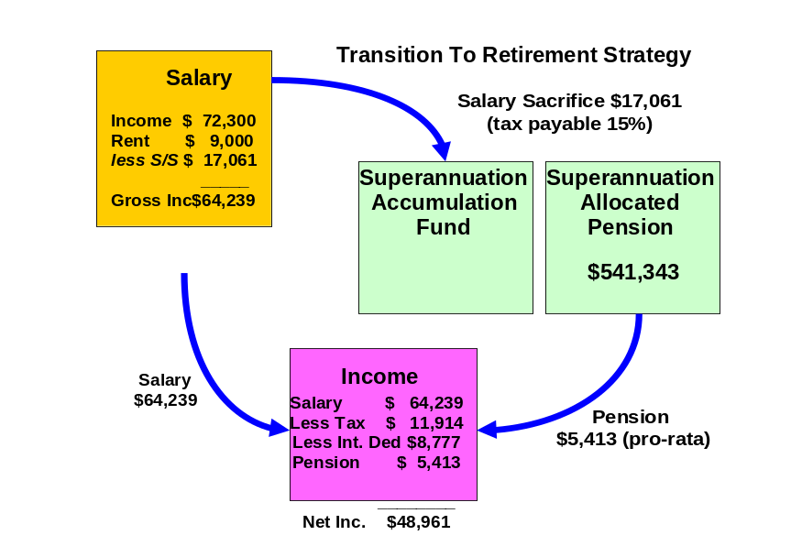

2011/12 FINANCIAL YEAR:
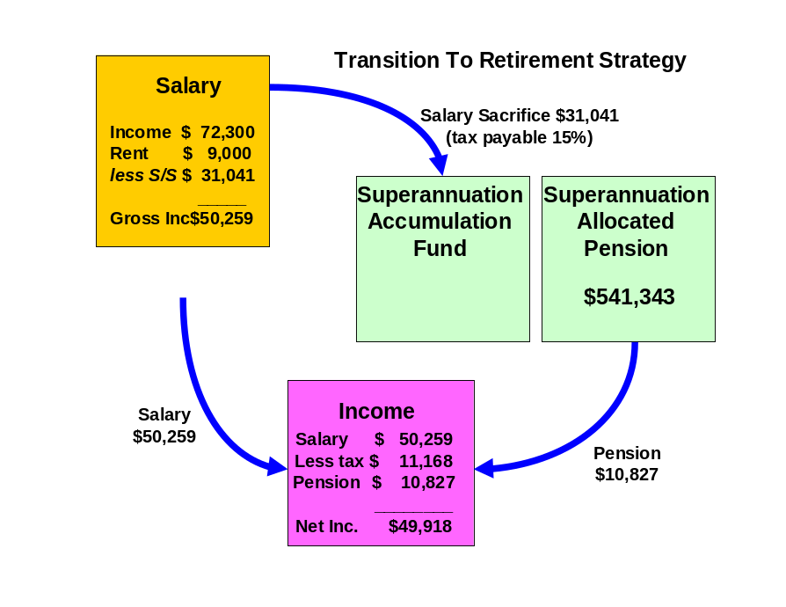

Jenny:

2010/11 FINANCIAL YEAR:
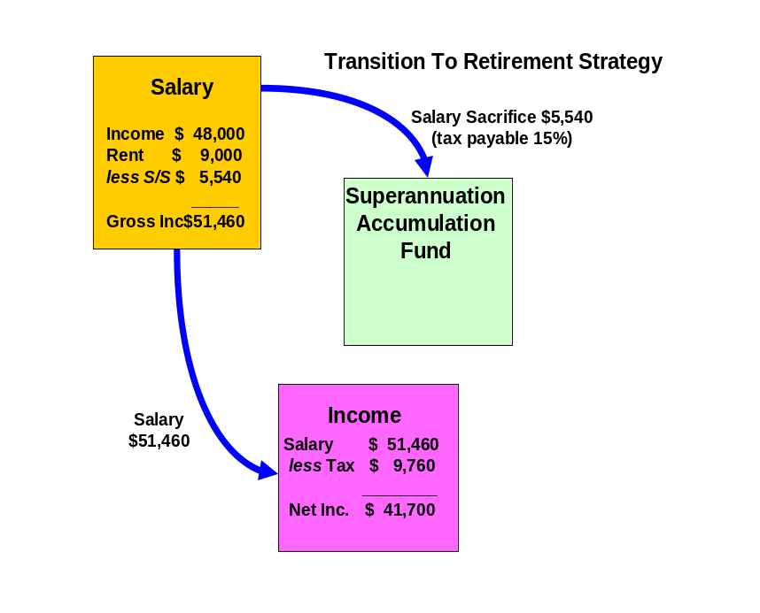

2011/12 FINANCIAL YEAR:
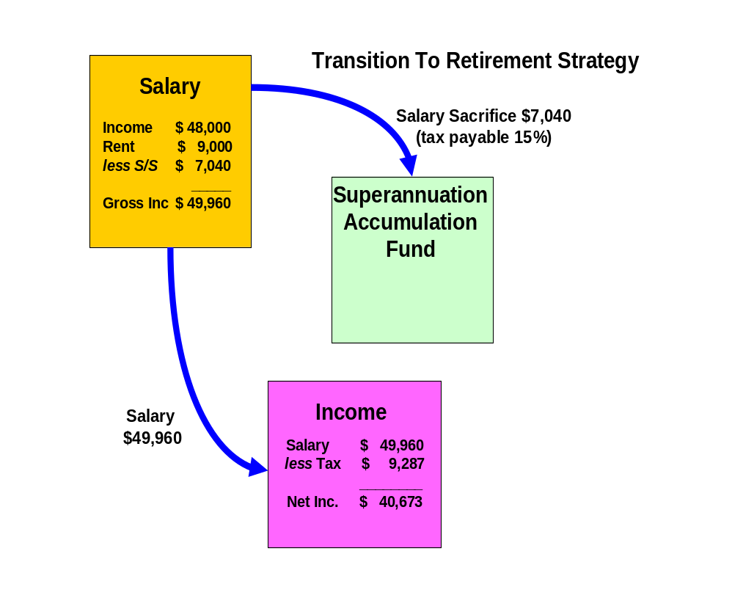

Reversionary Pensions

Recommendations:

Shane, when you commence your pre-retirement income stream (pension) you should make it reversionary.

Benefits:
- A reversionary pension enables your tax dependant beneficiary to receive your pension account balance remaining within the superannuation environment. All moneys received by the reversionary beneficiary remain in pension phase and therefore all income earned by the fund or capital gains realised by the fund to pay the benefit pension will not be subject to tax.
- If either the deceased or the recipient of the reversionary pension is over the age of 60, the income stream will not be assessable for income tax purposes.
Risks:

- If the income stream is commuted (either rolled into an accumulation fund or lump sums are withdrawn) within six months after the death of the deceased or 3 months after the grant of probate of that deceased person's will or letters of administration of that deceased person's estate, then it is treated as a death benefit payment. Therefore the moneys would be treated as a lump sum benefit outside of the superannuation environment.
- Death benefits in the form of a pension may only be paid to a “Tax Dependant” which will include the deceased members’ spouse, children under the age of 18 and persons financially dependent on the deceased member (and under the age of 25). In other words if the beneficiary did not fit the above description then they could only receive a lump sum and not a pension, thus they would lose the benefits of being in pension phase.
- If both the deceased member and the tax dependant are aged below 60 years then the pension will be included in the tax dependant’s assessable income less a 15% rebate until the tax dependant turns 60 years at which time the pension will be tax free.

Estate Planning

Although considerable emphasis is placed on wealth creation and protection, a third vital aspect of your financial strategy is the control of the manner in which your wealth will be distributed after your death.

The expression “Estate planning” represents the concept of the planning and documentation of your wishes for the distribution of your wealth following death, whether the assets are held personally or controlled by related entities such as trusts or companies.

Estate planning is a specialised area, and it is important that you obtain professional advice in relation to all areas of your estate plan. However we outline below some of the issues you should consider in designing your estate plan.

Wills and Testamentary Trusts

A Will is the first step in ensuring that the distribution of your estate is actioned in accordance with your wishes. If you die without a Will (intestate), it may be that a court will control both the manner of distribution of your estate and the persons to whom your estate is distributed, and this can cause unnecessary distress.

You have advised us that you have a Will, but it does not have testamentary trust provisions.

Recommendation:

- We have an arrangement with Lakeside Legal Pty Ltd who can assist with the implementation of an appropriate Will as soon as possible.
It is important to ensure your Wills:
  - Nominates executors (and substitute executors) who are likely to survive you and who clearly understand your wishes.
  - Nominates beneficiaries in relation to every segment of your estate and nominates alternative beneficiaries should your primary beneficiaries predecease you.
  - Bequeaths monetary value or a percentage of your estate rather than a specific asset, as there is the risk that an asset may not be in existence at the time of distribution of the estate.
  - Nominates assets to be held in trust for beneficiaries under 18 years of age. For example, you can provide funds for your children’s or grandchildren’s education.
  - Includes provision for the establishment of a testamentary trust, which can be a tax effective tool for distributing your estate.
Benefits:
- Peace of mind, knowing all your wishes are detailed to be carried out, and plans articulated for your immediate family to be adequately provided for in the event of your death.
- If your Wills incorporate a testamentary trust, your assets would pass into a discretionary trust (or multiple trusts) and be held for the benefit of your beneficiaries, (rather than directly by them).
- This way, each of your primary beneficiaries (e.g. your children) could be the trustee of their own individual testamentary trust which would allow them to control the distribution of capital and income to themselves, or amongst a range of secondary beneficiaries (e.g. the primary beneficiary's spouse and children).
- This could be determined on an annual basis having regard to each beneficiary's personal income and taxation circumstances (importantly, income distributed from a testamentary trust to minors is taxed at normal adult marginal tax rates), as well as family circumstances (assets held within a testamentary trust may provide some protection in the event of family breakdown or bankruptcy).

Non Estate Assets

It is important your estate planning arrangements incorporate your entire asset base.

Recommendation:
- We recommend you consult an approved legal practitioner. We have an arrangement with Lakeside Legal who will be able to assist you with this.

Although a Will constitutes a vital part of your estate planning arrangements, not all of your assets are automatically subject to the provisions of a Will. Examples of such ‘assets’ are as follows:
  - Superannuation assets – the Trustee of a superannuation fund is required to distribute your superannuation monies (including any life insurance benefits paid as a result of the death of the member) in accordance with the Trust Deed. You usually have the option of informing the Trustee of your preferences in relation to the distribution of your funds, but this may or may not be binding on the Trustee.
  - Jointly held assets – if assets are held as ‘joint tenants’, then upon the death of one of the owners the asset automatically passes in full to the other owner (no matter what is said in the Will of the deceased co-owner). On the other hand, assets held as ‘tenants in common’ are able to be disposed of as part of a Will.
  - Life insurance policies – depending on the ownership of the policy, benefits can be paid to the following - the deceased’s estate and therefore distributed through their Will (when the owner of the policy is also the insured person) - a person who has been nominated as the beneficiary of a policy by the deceased owner (in which case the beneficiary automatically receives the proceeds of the policy) - or any third party who owns the policy.
  - Assets owned by a Trust – these assets are legally owned by the Trustee of the Trust and therefore are not able to be dealt with through a person’s Will.
(Note: In recent times, the use of Trusts as an estate planning vehicle has become wide spread and your solicitor or other business adviser should be consulted if you wish to exercise a measure of control over the way in which Trust assets are managed or distributed. For example if a company acts as trustee for a Trust, you may retain an interest in the company and therefore the trust by owning shares in that company.)
  - Assets owned by a company – only the deceased’s shares in the company may be dealt with through their Will.

Powers of Attorney

This element of your estate plan is designed to be implemented prior to your death so that your affairs can be conducted appropriately.

You have advised us you have current Medical and Financial Powers of Attorney (POA) (i.e. reviewed within the last three years).

Recommendation:

- We recommend you adopt an ongoing review strategy every three years (or earlier if your circumstances change).
- We recommend you consult an approved legal practitioner. We have an arrangement with Lakeside Legal Pty Ltd who will be able to assist you with this.

There are three ‘standard’ types of Power of Attorney:

- A general Power of Attorney which can provide the donee with restricted or unrestricted authority over the donor’s financial affairs (but not their health care). Such a policy lapses if the donor loses mental capacity.
- An enduring Power of Attorney which provides the donee with authority over the donor’s financial affairs (but not their health care) until they die (i.e. it extends beyond any loss of mental capacity).
- An enduring medical Power of Attorney which provides the donee with authority over the medical needs of the donor if the donor himself is unable to make such decisions (whether temporarily or permanently).
Note 1 - A Power of Attorney may only be granted by someone who is over the age of 18 and who is of sound mind at the time of the grant and capable of fully understanding the nature and purpose of the document they are signing.
Note 2 - The attorney is not able to do anything illegal while operating under a Power of Attorney, nor is he/she able to sign a Will on behalf of the donor, or to transfer the Power of Attorney to someone else unless authorised to do so.

Risk Management

The objective of having insurance cover over your life and your assets is to protect yourself and your family from financial distress in the event of death, illness or accident. Where such an event occurs there is often considerable emotional distress. Financial planning aims to remove the financial distress at such a time.

There are two ways you can manage this type of risk:

- Self insurance; or
- Transfer of the risk/insurance to an insurance company.

There are many instances where people effectively elect to self-insure through lack of planning. This means an event occurs which causes financial distress and people manage on what they have set aside. Other ways of self insuring are by planning and setting aside funds for protection in such an event. The most common form is, however, to recognise the risk and evaluate how much protection is required and then transfer that risk to an insurance company.

Personal Insurance - Review Recommendation

Managing risk is an important part of the financial planning process in order to provide protection against possible future financial loss. Insurance is a simple precaution you can take to protect against the financial consequences of premature death, a medical crisis, total and permanent disablement or temporary disablement.

Existing Cover Amounts

Shane presently has:
Life Insurance: $396,012
TPD: $396,012
Income Protection: $42,228 per annum

Jenny presently has:
Life Insurance: $9,000
TPD: $9,000
Income Protection: $29,278.08 per annum

Mark Butler has had discussions with you with respect to your existing cover and you have advised that you do not wish to make any changes/additions to the levels of cover detailed above.

Investment Recommendations

After considering your investment profile, your financial objectives, the current economy and economic trends, we recommend that your funds be invested in the following manner.

Current Portfolio
ASSETS
Lifestyle Assets | Value
Residential Home | $400,000
Home Contents | $50,000
Total Lifestyle Assets | $450,000

Investment Assets
Investment Property – Alphington | $600,000
Experian Shares | $75,000
Great Southern Plantations | $21,000
Cash | $60,000
IOOF Managed Fund | $101,194
Total Investment Assets | $857,194

Superannuation Assets
Shane
Colonial | $202,471
Asteron - Optimum | $325,926
Uni Super | $17,956
 | $546,353
Jenny
Russell Super | $74,692
IOOF | $11,274
 | $85,966
Total Superannuation Assets | $632,319

Total ASSETS | $1,939,513

LIABILITIES
Personal Loans
Credit Card | $2,000
Home Loan | $80,000
Total Personal Loans | $82,000

Investment Loans
IOOF Investment Loan | $100,000
Experian Shares | $60,000
Great Southern Plantations | $21,000
Total Investment Loans | $181,000

Total LIABILITIES | $263,000

NET WORTH | $1,676,513

Proposed Portfolio

ASSETS
Lifestyle Assets | Value
Residential Home | $400,000
Home Contents | $50,000
Total Lifestyle Assets | $450,000

Investment Assets
Investment Property – Alphington | $600,000
Experian Shares | $75,000
Great Southern Plantations | $21,000
Cash | $60,000
IOOF Managed Fund | $0
Total Investment Assets | $756,000
Superannuation Assets
Shane
Colonial | $0
Asteron - Optimum | $0
Uni Super | $5,000
Colonial First State Wholesale Pension
BT Wholesale Core Australian Share | $45,474
Fidelity Wholesale Australian Equities | $45,474
Perennial Wholesale Value Australian Share | $38,977
BT Core Wholesale Global Share Fund (AQR) | $18,947
Platinum Wholesale International | $11,368
Perpetual Wholesale International Share Fund | $18,947
MFS Wholesale Global Equity | $26,526
BT Wholesale Property Securities | $18,947
RREEF Wholesale Property Securities | $13,534
CFS WS Colliers Global Property Securities | $21,654
FirstChoice Wholesale Fixed Interest | $205,714
CFS Wholesale Cash Fund | $75,789
 | $541,353
Jenny
Russell Super | $76,492
IOOF | $9,474
 | $85,966
Total Superannuation Assets | $632,319

Total ASSETS | $1,838,319

LIABILITIES
Personal Loans
Credit Card | $2,000
Home Loan | $80,000
Total Personal Loans | $82,000

Investment Loans
IOOF Investment Loan | $0
Experian Shares | $60,000
Great Southern Plantations | $21,000
Total Investment Loans | $81,000

Total LIABILITIES | $163,000

NET WORTH | $1,675,319

Projected Portfolio Profile Compared to Benchmark

Shane:

Asset Class | Projected Portfolio | Benchmark Profile for Mod Conservative | Deviation
Australian Shares | 19% | 24% | -5%
International Shares | 12% | 19% | -7%
Property | 40% | 9% | 31%
Fixed Interest | 23% | 38% | -15%
Cash | 6% | 10% | -4%
Other | 0% | 0% | 0%

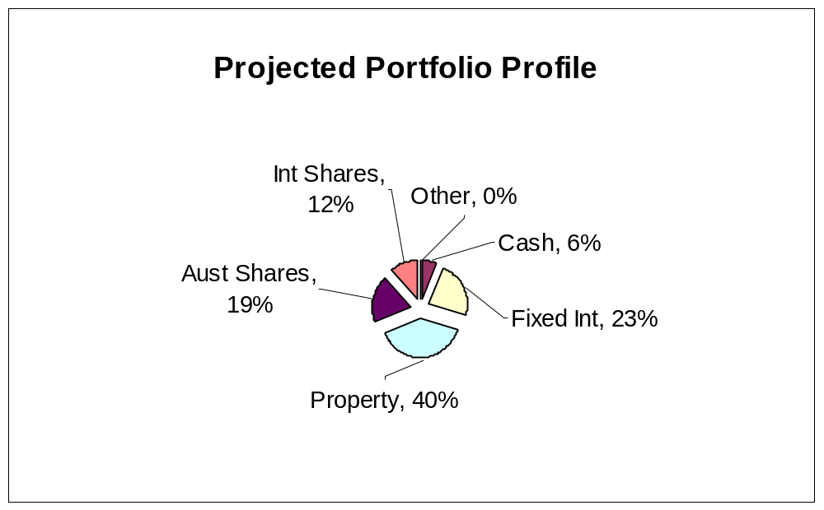

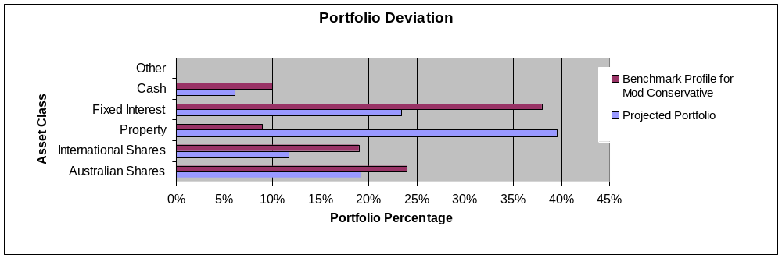

As an industry standard, a variance of 10% within a particular asset class is allowed to cater for individual circumstances, economic events and fund manager asset allocation decisions. Variations outside of this range may be appropriate in certain circumstances.

This said, considering your portfolio is outside the standard in some assets, I have included a commentary for the reasons surrounding this:

- The asset allocation noted above falls outside the Investor profile guidelines for a Moderately Conservative Investor. This is in large part due to the fact that your investment property makes up such a large portion of the total balance of your portfolio.

Jenny:
Asset Class | Projected Portfolio | Benchmark Profile for Cash | Deviation
Australian Shares | 9% | 0% | 9%
International Shares | 0% | 0% | 0%
Property | 69% | 0% | 69%
Fixed Interest | 0% | 0% | 0%
Cash | 23% | 100% | -77%
Other | 0% | 0% | 0%

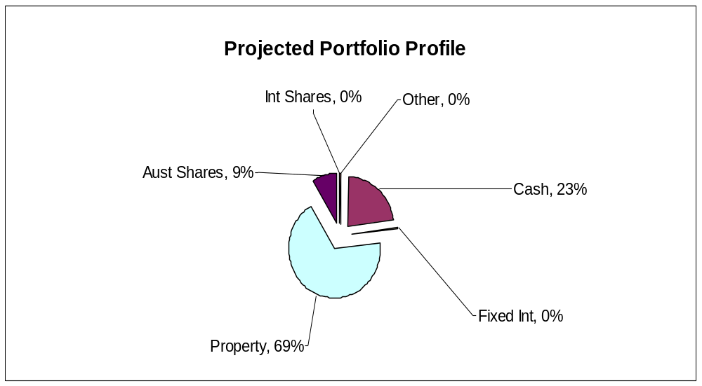
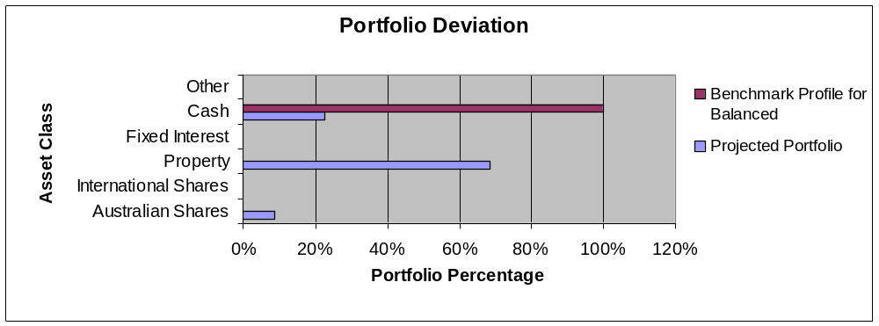

As an industry standard, a variance of 10% within a particular asset class is allowed to cater for individual circumstances, economic events and fund manager asset allocation decisions. Variations outside of this range may be appropriate in certain circumstances.

This said, considering your portfolio is outside the standard in some assets, I have included a commentary for the reasons surrounding this:

- The asset allocation noted above falls outside the Investor profile guidelines for a Cash Investor. This is in large part due to the fact that your investment property makes up such a large portion of the total balance of your portfolio.

Colonial FirstChoice Wholesale Investments
The FirstChoice Wholesale Investments is a multi-manager investment solution which combines wide investment choice with a competitive and simple fee structure, backed up by a high standard of service support from Colonial First State.

The minimum initial investment the Colonial FirstChoice Wholesale Investments Plan accepts is $100,000. There is no minimum additional investment amount required, however minimum regular investment and withdrawals are set at $500. Regular payments can also be made by BPay. You can then monitor and manage your investments over the Internet, by phone or through your financial adviser.

Reasons and Benefits
The major features of the Colonial FirstChoice Wholesale Investments are as follows:

Sector Specific Diversification
A strong range of investment options with access to more than one specialist manager within each asset class. This approach captures the competitive advantages of each manager. We anticipate this will provide higher returns than can be obtained from using diversified funds with, say, only one fund manager.

Simplicity
Consolidated reporting from Colonial First State.

Ease of Management
Automatic investment re-balancing and switching to help you easily and conveniently keep your investment strategies on track.
- We recommend that annual automatic rebalancing is elected.

Highly competitive and simple to understand fee structure
- No entry fee applies to this investment however, with your agreement; your Financial Adviser may wish to charge a one off fee to cover upfront costs.
- An ongoing management fee ranging from 0.31% p.a. to 2.96% p.a. applies, depending on investment options chosen. This fee is all inclusive, covering Colonial First State's administration fee and investment management fee. No ongoing remuneration is paid to Guardian Financial Planning out of this fee.
- The weighted average management fee for the Colonial FirstChoice Wholesale Investments Plan is 1.11% for Growth, 1.37 for High Growth and 1.2% for Gearing.
- You can agree with your Financial Adviser to have an ongoing Adviser Service Fee for advice paid directly from your investment. The ongoing fee will be deducted monthly from your investment options.
  - Our normal 0.75% p.a. Adviser Service fee will apply.
- No switching fees or exit fees apply to this investment.
- Within the Wholesale Investment plan a buy-sell spread of between 0 – 0.55% applies depending on investment option. Please refer to the Product Disclosure Statement for details.
Colonial FirstChoice Management Fee
Colonial FirstChoice charges a Management Expense Ratio to cover their administration costs and the associated costs of managing your funds and the advisers trail fee. Based on your current portfolio value, we have provided an estimation of the costs you will pay.

Shane:

Colonial FirstState FirstChoice Investments | MER  % | Amount invested  $ | Estimated  fee  $
BT Wholesale Core Australian Share | 1.00% | $45,474 | $455
Fidelity Wholesale Australian Equities | 1.05% | $45,474 | $477
Perennial Wholesale Value Australian Share | 1.00% | $38,977 | $390
BT Core Wholesale Global Share Fund (AQR) | 1.30% | $18,947 | $246
Platinum Wholesale International | 1.80% | $11,368 | $205
Perpetual Wholesale International Share Fund | 1.35% | $18,947 | $256
MFS Wholesale Global Equity | 1.20% | $26,526 | $318
BT Wholesale Property Securities | 1.05% | $18,947 | $199
RREEF Wholesale Property Securities | 0.80% | $13,534 | $108
CFS WS Colliers Global Property Securities | 1.00% | $21,654 | $217
FirstChoice Wholesale Fixed Interest | 0.75% | $205,714 | $1,543
CFS Wholesale Cash Fund | 0.40% | $75,789 | $303
Total ongoing fees  | 0.87% | $541,353 | $4,717

 Colonial FirstChoice’s Management Fee is calculated on the value of your total portfolio. As such we have used you current portfolio to estimate your annual ongoing fee.

Shane - Please note that there is an additional adviser service fee of 0.75% that is paid by you.

Additional details of the above fees are outlined in the Colonial’s Product Disclosure Statement.

Replacement of an Existing Product
Shane:

Type of Fee or Cost | Asteron Optimum Super Fund | Uni Super | Colonial Wholesale Pension Fund
Contribution/Entry fee – this is the fee for initial and subsequent contributions. | 4.1% | Nil | Nil
Withdrawal/Exit Fee – this is the fee for each withdrawal you make | $50 | Nil | Nil
Switching Fee – fee charged for switching between investment options in the super fund. | Nil | Nil | Nil
Administration Costs – are the fees and costs that cover the operation of the fund. They include admin, member and other fees charged by the product issuer | $5,741.70 p.a. (Comprises of $4.80 p.m. Member Fee + 1.05% Admin Fee) | $120 p.a. | Nil
Adviser Service Fee – additional fee paid to financial adviser | Nil | Nil | 0.75%
Investment Costs - Current – are the fees and costs the product issuer charge for investing the assets. These include fees paid to external fund mgrs. | 0.8413% | 0.69% | 0.87%
Annual average cost - Total $541,343 investment | $10,296 | $3,855 | $8,769
Investment Costs –  Relevant to Your Risk Profile | 0.75% | 0.29% | Same as above
Annual average cost – Relevant to Your Risk Profile (on same balance as above) | $9,802 | $1,690 | Same as above
Amount of Insurance Cover – Life, TPD and Income Protection held inside super | $396,012.91 Life/TPD | n/a | $396,012.91 Life/TPD
Cost of above insurance cover per annum. | $3,452 | n/a | $3,735

The investment cost will vary depending on which fund you are invested in, the assets it invests into and how actively they manage their portfolios, amongst other things. Typically these costs should not be compared directly.

Outcomes Post Recommendation:
- Shane, you are gaining access to a pension fund which provides the benefits that we have previously outlined.
- Shane, the sum of your total ongoing management and administration fees will potentially be reduced resulting in a saving of approximately $941 p.a. if your funds were to remain at present.
- You will gain access to a diversified portfolio of funds that matches your investor risk profile and investment objectives.
- You will have the ability to implement the documented strategies and have these reviewed on a regular basis.

Cash Flow Projections Post Recommendation
Following the implementation of this strategy and investment recommendations within this report we estimate that your future tax liabilities and cash flows to be as follows.

Estimated Tax Liability for Shane 2010/11
Income Source |  | Amount Received | Deduction | Taxable Income | Tax
Gross Salary |  | $72,300
Investment Property (net) income |  | $9,000
Pension Income Stream |  | $5,413
Deductions |  | $86,713
Current Salary Sacrifice |  |  | $5,061
Super Contributions |  |  | $12,000
Interest of investments ($181K @ 6.70% for 6 months & $81K for 6 months @ 6.70%) |  |  | $8,777
TAXABLE INCOME |  |  |  | $60,875
Tax payable before rebates/credits |  |  |  |  | $11,813
Medicare Levy |  |  |  |  | $913
Net Tax before rebates/credits |  |  |  |  | $12,726
Income Stream Rebate |  |  |  |  | $812
NET TAX |  |  |  |  | $11,914

Estimated Tax Liability for Jenny 2010/11
Income Source |  | Amount Received | Deduction | Taxable Income | Tax
Gross Salary |  | $48,000
Investment Property (net) income |  | $9,000
Deductions |  | $57,000
Current Salary Sacrifice |  |  | $1,040
Super Contributions |  |  | $4,500
TAXABLE INCOME |  |  |  | $51,460
Tax payable before rebates/credits |  |  |  |  | $8,988
Medicare Levy |  |  |  |  | $772
Net Tax before rebates/credits |  |  |  |  | $9,760
NET TAX |  |  |  |  | $9,760

Current Estimated Cash Flow 2010/2011
Based on your stated income, expenses and current tax position we estimate your cash flow over one whole financial year to be as follows.
 | Shane | Jenny | Total
Income
Income Received - Salary | $72,300 | $48,000 | $120,300
Income Received – Rent | $9,000 | $9,000 | $18,000
Income Received - Pension | $5,413 | $0 | $7,218
Sub Total | $86,713 | $57,000 | $145,518
Less Income Tax | $11,914 | $9,760 | $19,515
Less Current Salary Sacrifice | $5,061 | $1,040 | $6,101
Less Interest on Investments | $8,777 | $0 | $8,777
Less Additional Salary Sacrifice | $12,000 | $4,500 | $24,300
Net Income | $48,961 | $41,700 | $90,258
Less budgeted expenditure | $47,855 | $42,283 | $90,138
Income Surplus | $1,106 | ($583) | $523

Estimated Tax Liability for Shane 2011/12
Income Source |  | Amount Received | Deduction | Taxable Income | Tax
Gross Salary |  | $72,300
Investment Property (net) income |  | $9,000
Pension Income Stream |  | $10,827
Deductions |  | $92,127
Current Salary Sacrifice |  |  | $5,061
Super Contributions |  |  | $25,980
TAXABLE INCOME |  |  |  | $61,086
Tax payable before rebates/credits |  |  |  |  | $11,876
Medicare Levy |  |  |  |  | $916
Net Tax before rebates/credits |  |  |  |  | $12,792
Income Stream Rebate |  |  |  |  | $1,624
NET TAX |  |  |  |  | $11,168

Estimated Tax Liability for Jenny 2011/12
Income Source |  | Amount Received | Deduction | Taxable Income | Tax
Gross Salary |  | $48,000
Investment Property (net) income |  | $9,000
Deductions |  | $57,000
Current Salary Sacrifice |  |  | $1,040
Super Contributions |  |  | $6,000
TAXABLE INCOME |  |  |  | $49,960
Tax payable before rebates/credits |  |  |  |  | $8,538
Medicare Levy |  |  |  |  | $749
Net Tax before rebates/credits |  |  |  |  | $9,287
NET TAX |  |  |  |  | $9,287

Current Estimated Cash Flow 2011/2012
Based on your stated income, expenses and current tax position we estimate your cash flow over one whole financial year to be as follows.
 | Shane | Jenny | Total
Income
Income Received - Salary | $72,300 | $48,000 | $120,300
Income Received – Rent | $9,000 | $9,000 | $18,000
Income Received - Pension | $10,827 | $0 | $10,827
Sub Total | $92,127 | $57,000 | $149,127
Less Income Tax | $11,168 | $9,287 | $17,715
Less Current Salary Sacrifice | $5,061 | $1,040 | $6,101
Less Additional Salary Sacrifice | $25,980 | $6,000 | $40,680
Net Income | $49,918 | $40,673 | $90,591
Less budgeted expenditure | $47,855 | $42,283 | $90,138
Income Surplus | $2,063 | ($1,610) | $453

What is paid to your adviser

Plan Fee

You have agreed to a Plan Fee of $1,650 (inclusive of GST), of which $1,650 will be deducted from Shane’s superannuation fund.

Upfront and Ongoing Fee Disclosure

The following is provided to assist you to gain a clear understanding of the payments and benefits that Guardianfp Limited, our associates and I will be entitled to receive for services provided to you, if you adopt the recommendations in this plan.

 |  |  | Total Fee Paid by Client |  | Total Fee Payable to Financial Service Licensee/Financial Adviser and /or its Associates
Investment Details |  | Amount Invested | (%) ($) |  | Initial  (%) ($) |  | Ongoing  (%) ($)
Shane - Colonial FC Wholesale Pension |  | $541,343 | Flat Fee | $1,650 | Flat Fee | $1,500 | 0.75 | $4,060
Total |  | $541,343 |  | $1,650 |  | $1,500 |  | $4,060

My associates and I will receive 100% of the fee payable disclosed above, as a flat annual fee is paid to Guardianfp Limited.

* The ongoing investment amount has been annualised to provide you with a clear picture of how commission and fees are paid from your investment. Your regular contribution is placed into the individual underlying funds according to the % split of the allocation of your original investment.

Ongoing fee is generally paid until the investment is redeemed. The actual amount will vary over time according to the mix of the underlying investments and the total value of your funds under management.

Disclosure Statement

To help you understand the full benefits, details and risks of our recommended products, please read the Product Disclosure Statements that we will provide you.

Please let us know if you have any questions.

Cooling-off periods

After investing in a financial product, you have a “cooling-off” period in which to change your mind if you don’t think the product meets your needs. The cooling-off period usually starts when you’re told the product has been set up. The length of the period varies with each product.

Each Product Disclosure Statement explains your cooling-off rights.

If you wish to cancel a product, please tell us in writing so we can contact the product issuer within the time restrictions.

No guarantee

The investments we recommend for you must be appropriate for you. However, we don’t guarantee they’re the best available or that they’ll perform in a particular way. Product performance depends on the features and risks described in the Product Disclosure Statements given to you.

Please take the time to read the PDS and understand the products we have recommended. If you have any questions, please contact us.

Tax

There will be tax implications if you act on this advice. We recommend you ask a tax professional to assess the impact on your short and long-term financial positions.

Are My Product Recommendations Restricted?

Non Superannuation Products

Yes, when making non superannuation product recommendations I can only choose products from our Approved Product List (APL). This list is compiled by a dedicated Investment Committee, made up of Research Manager, Directors and Representatives who carefully analyse investment products, prior to including any product on the APL. The Committee utilises leading industry research houses to assist with their analysis.

The APL is regularly reviewed to ensure that all funds, managers and investment companies continue to meet our ongoing stringent requirements.

Superannuation Products

Yes, when making superannuation product recommendations I can only choose products from our Approved Product List (APL). However, if you have a superannuation product that is not on our APL, I am still able to make recommendations in relation to that fund providing I have conducted the necessary research and have a thorough knowledge of the fund.
.
Insurance Products

I can recommend policies from a list of insurance companies and their products that are currently researched by Rice Walker Research.

What is My Responsibility to You?

I am responsible for providing you a ‘clear, concise & an effective’ method of communicating my recommendations to you. The recommendations are based on your goals and objectives, personal and financial situations, and other information collected from you. The recommendations are appropriate for your needs and current situation.

As the SoA is specifically prepared for you and based on your situation, I do not take any responsibility for any third party persons acting on all or on a part of any advice or recommendations made in this SoA.

Do I Guarantee the Investments I have recommended?

No. By law, the investments I have recommended must be appropriate to you, however, I do not guarantee that the recommended investments are the best for you or that they will perform in a certain way.

I have included financial projections (please refer to the Appendix) to illustrate key aspects of my advice to you, however, they are assumptions and estimations only, and they are not guaranteed to occur over the timeframe of the SoA-contained projections.

Is Your Personal Information Protected?

We may be required from time to time, to disclose information about you to representatives of Guardian Financial Planning, and other companies within the Promina Group and to other professionals, insurance providers, superannuation trustees, regulators and product issuers in order to provide our services and arrange for the issue of Financial Products.

Please ensure you have read the ‘How we handle your Personal Information’ section of the Financial Services Guide (FSG) for more information.

Summary

Plan Implementation

Shane and Jenny, you have taken another next step to reach your personal and financial goals and objectives. The most important stage of the process is to put the plan into action. There are a number of steps required for the implementation of this plan:

Action | Anticipated Start Date | Estimated Completion Date | Responsibility
Detailed review of the recommendations | 4th November 2010 | 14th November 2010 | Shane, Jenny
Authority to Proceed returned with any amendments | - | 14th November 2010 | Shane, Jenny
Applications returned | - | 14th November 2010 | Shane
Sale of IOOF | 14th November 2010 | 30th November 2010 | Lee Hutchison
New Pension Fund Application Process | 1st January 2011 | 14th January 2011 | Lee Hutchison
Consolidate superannuation accounts | 1st December 2010 | 14th December 2010 | Lee Hutchison
Pension Application Process | 30th November 2010 | 30th December 2010 | Lee Hutchison
Confirmation of all in place | - | 14th January 2011 | Andrew Lord
Book Post-Implementation / Review Appointment | - | May/June | Shane, Jenny  Andrew Lord

Your Financial Plan

In preparing this plan we have taken into account your specific goals and objectives, and have designed an appropriate strategy that aims to accomplish these.

It is important to appreciate that we live in an ever changing world. Accordingly, it is probable that, overtime, the basis of our calculations (inflation rates, investment rates etc) will change, as will your own requirements and expectations. It is therefore recommended you review your plan on a regular basis to ensure you are still on track to achieve investment objectives.

It is essential to have your investment portfolio reviewed to ensure that the investments are working to their maximum potential and any changes to the investment markets, taxation etc. are promptly and correctly responded to.

Next steps

How to get started

To implement our recommendations in this plan, please do the following:

- Make sure you read this Statement of Advice and Product Disclosure Statements
- Contact us if you have any questions
- Tell us immediately if any information is incorrect
- Complete the application forms in the Product Disclosure Statements
- Sign and date the Authority to Proceed
- Return the forms to us
- Retain a copy for your records

Finally

Please note, as with any investments, their future value may fluctuate, particular rates of return cannot be guaranteed and you may not get back what you originally invested. We have provided a brief summary of the managed investment products recommended, however, you will need to study the investment statements of the recommended products carefully before you decide to invest.

Appendix – Assumptions

In preparing your financial strategy, it is necessary to make certain assumptions. These are outlined below.

- Current superannuation rules, taxation legislation and social security rates have been used;
- Asset allocations for your risk profile are based on directions from Guardian FP in conjunction with research from research house van Eyk;
- Life expectancies from the Australian Life Table 2000/02 have been used where relevant;
- Where applicable Medicare Levy of 1.5% is included on marginal tax rates;
- Throughout this plan, an inflation rate of 3% per annum has been used, and a default rate of return of 7% on share and managed fund investments. Projections are calculated in today’s dollars;
- Superannuation contributions tax of 15% is taken into consideration where relevant;
- There is no tax on the earnings within pension products.
- No consideration has been made for Eligible Termination Payments, foreign sourced income or capital gains or losses, unless stated otherwise;
- 100% franking is assumed on all Australian share distributions at a rate of 70%. An expected dividend yield of 3.5% is used in all income calculations;
- Where estimated tax liability has been calculated involving managed funds, an assessable capital gain of 5% of the portfolio value has been assumed.
- Cash flow projections are based on estimated income of your investment portfolio and any other income such as salary. Estimated expenses and tax are also included;

Authority to Proceed

I Shane O'Meara and I Jenny O'Meara of
4 Balmerino Square
FRANKSTON VIC 3199

State that:

We have read and understood the Financial Plan presented to us by Andrew Lord B Bus (Acc), Dip FS (Fin Plan) from Guardianfp Ltd trading as Guardian Financial Planning, and authorise him to proceed with the recommendations as outlined below:

Investment | Amount
Shane - Colonial FirstChoice Wholesale Pension | $541,343

All fees and charges have been explained to us.

We authorise Andrew Lord B Bus (Acc), Dip FS (Fin Plan) to act in his capacity as our Financial Adviser regarding these investments and to act on our instructions provided by (tick whichever is applicable):

- Facsimile

- Email

- Writing

We acknowledge that:

- We have received and read a Financial Services Guide.
- We have provided all information to the best of our knowledge for the preparation of this Statement of Advice.
- Our adviser is not a taxation adviser, and estimates of tax positions are estimates only.
I/We should seek advice from a registered tax agent for taxation advice.

q We accept the recommendations made in this Report and give authority to Guardianfp Ltd
ABN 40 003 677 334 to proceed with the implementation of those recommendations.

Modifications to recommendations requested by client

Signed: | _________________________________ | ____/______/______
 | Shane O'Meara | Date
Signed: | _________________________________ | ____/______/______
 | Jenny O'Meara | Date
Signed: | _________________________________ | ____/______/______
 | Andrew Lord  B Bus (Acc), Dip FS (Fin Plan) | Date

